FTF FY 2023 Performance Scorecard USAID Pakistan

This Feed the Future (FTF) Performance Scorecard assesses the USAID Pakistan progress toward FY 2030 Performance Targets.

# Performance Overview



The FY 2023 **On track** value is determined by drawing a line from the baseline (FY 2022) to the FY 2030 Target. For FY 2023, Performance Targets are considered **On track** if they have reported at least 90% of that value.

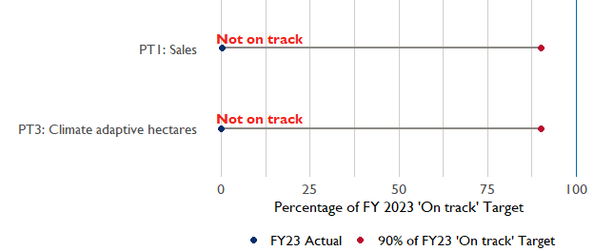

**Note:** *For Performance Target 2 (Gender financing ratio), the target is to increase financing to females for those OUs that are already achieving parity ($1).*

*For Performance Target 4 (PSI), all targets are relative to the last three years’ reporting. In future years, the interim targets may increase.*

*For Performance Target 5 (MDD-W), all FY23 actual values are also the baseline, and may have been collected in a prior year. See the detail page for more information.*

*See detailed* [*methodology document*](https://docs.google.com/document/d/13n-43ppFiGKauscQ7HaAiQDCM4DssGEgRdq2fMyTDn0/edit) *here. If you have questions, please email the FTF Data and Analytics team at* [refs.adl.da@usaid.gov](mailto:refs.adl.da@usaid.gov).

### Performance Target (PT) Details

This section shows PT scores for each applicable PT for USAID Pakistan.

## Performance Target 1: Value of annual sales of producers and firms receiving USG assistance



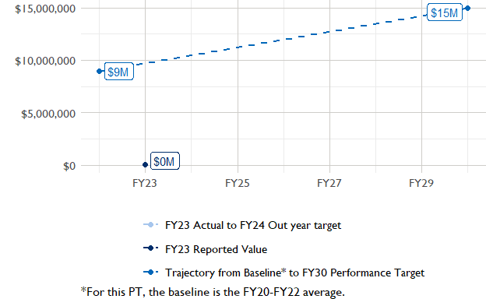

In FY 2023, USAID Pakistan had 2 activities that aligned the ‘Value of annual sales from producers and firms receiving USG assistance’ (EG.3.2-26), and 2 contributed to the sales total of $30,000.

###### Performance Target 2: Value of financing accessed by female FTF participants per $1 of financing accessed by male FTF participants



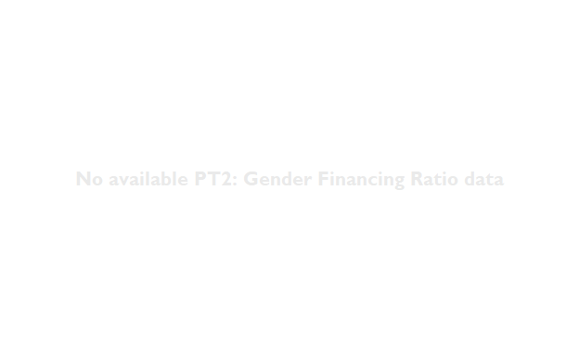

In FY 2023, USAID Pakistan had 0 IMs/Activities that reported all four sex disaggregates needed to contribute to PT2. The total value of financing among all activities, regardless of disaggregates, was NA (EG.3.2-27 total), with NA that was disaggregated by females and males, and an additional 0 to ‘mixed’ firms that have both males and females, and NA that was not sex disaggregated.

###### Performance Target 3: Number of cultivated hectares under climate adaptation/climate risk management practices and technologies with USG assistance



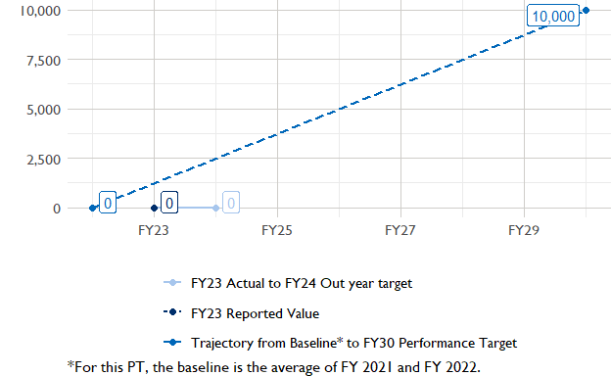

In FY 2023, USAID Pakistan had 7 activities that aligned the indicator for hectares under improved management practices (EG.3.2-25). Of those activities, 0 reported on the ‘Climate adaptation/climate risk management’ disaggregate and contributed to the OU total for this PT.

###### Performance Target 4: Value of private sector investment leveraged by the USG to support food security and nutrition



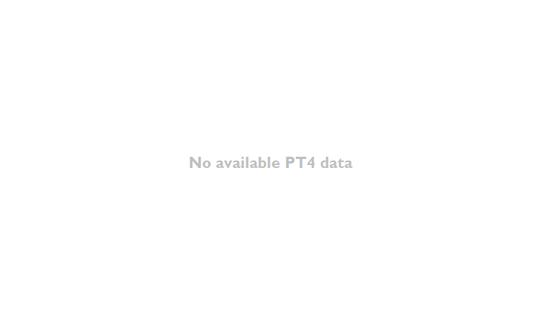

USAID Pakistan did not report on EG.3.1-15 in FY 2023.

###### Performance Target 5: Percent of women consuming a diet of minimum diversity (MDD-W)



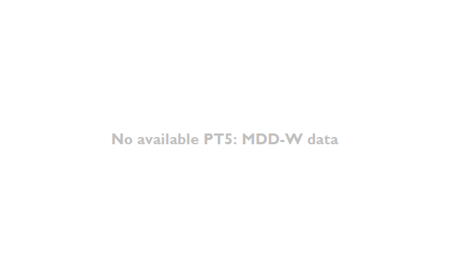

PT5 is not available for USAID Pakistan.

### National Context

National level data was collected from the [World Bank’s Open Data portal](https://data.worldbank.org/) that measures key indicators at the national level.

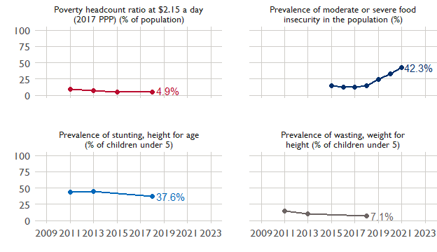

## Agricultural Transformation Index Score

The IFPRI Agricultural Transformation Index (ATI) Score is a high level indicator of the status of agricultural market systems in each country.

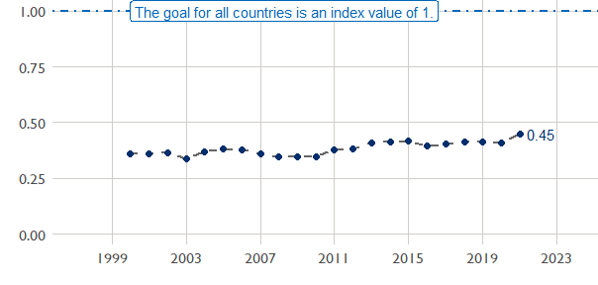

## Budget Trend

At the Operating Unit level, the Performance Targets are based in part on the FY 2024 budget request. The budget chart below includes EG.3 money only.

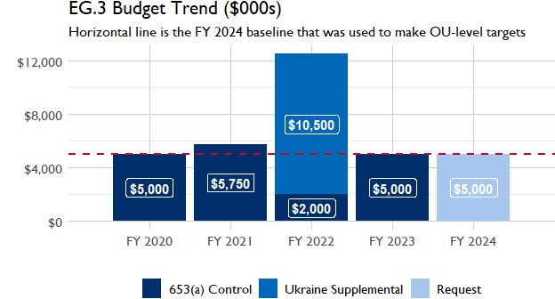

## Active Portfolio

The following activities are considered “active” based on their reporting in FY 2023 and expected FY 2024 reporting. The Analytics, Data and Learning Division defines an “active” activity as one that reported targets, actuals, or deviation narratives for the current year (FY 2023), or the next out year targets (i.e. FY 2024).

## Top Activities (Award Disbursements and Results)

This section highlights the 5 activities (out of the total 7 in the USAID Pakistan (PAKISTAN) portfolio) that have the highest level of FY 2023 annual disbursements and highest reported values for the relevant indicators. The first table below shows activities with the highest total transaction amounts. The columns to the right indicate if these activities are reporting on relevant PT indicators.

| Award Number | Activity Code | Activity Name | FY23 Disbursements | PT1 | PT2 | PT3 | PT4 |
| --- | --- | --- | --- | --- | --- | --- | --- |
| 72039122CA00001 | 1902 | Economic Recovery and Development Activity | $3,408,781 | - | - | - | - |
| 72039118IO00004 | 1903 | The Horticulture Advancement Activity (THAzA) | $1,380,000 | X | - | - | - |
| 72039118IO00003 | 1897 | Water Management for Enhanced Productivity | $1,109,342 | - | - | - | - |

The next table (below) shows the activities that reported the highest values for the relevant PT indicators. The total disbursements are included, if available.

| Award Number | Activity Code | Activity Name | Total Disbursements | PT1: Sales | PT3: Climate adaptive hectares | PT4: PSI |
| --- | --- | --- | --- | --- | --- | --- |
| 72039118IO00004 | 1903 | The Horticulture Advancement Activity (THAzA) | $1,380,000 | $25,748 | NA | NA |
| AID-391-C-17-00004 | 1898 | Pakistan Agricultural Technology Transfer Activity (PATTA) | NA | NA | NA | NA |
| 72039118IO00003 | 1897 | Water Management for Enhanced Productivity | $1,109,342 | NA | NA | NA |
| 72039121T00001 | 5593 | Pakistan Agriculture Program II | $585,088 | NA | NA | NA |
| 72039122CA00001 | 1902 | Economic Recovery and Development Activity | $3,408,781 | NA | NA | NA |
| !! Not reported !! | 1899 | Gomal Zam Dam Command Area Development Project | NA | NA | NA | NA |
| !! Not reported !! | 5965 | Livelihood and Food Security Fund in flood affected districts of Pakistan | NA | NA | NA | NA |

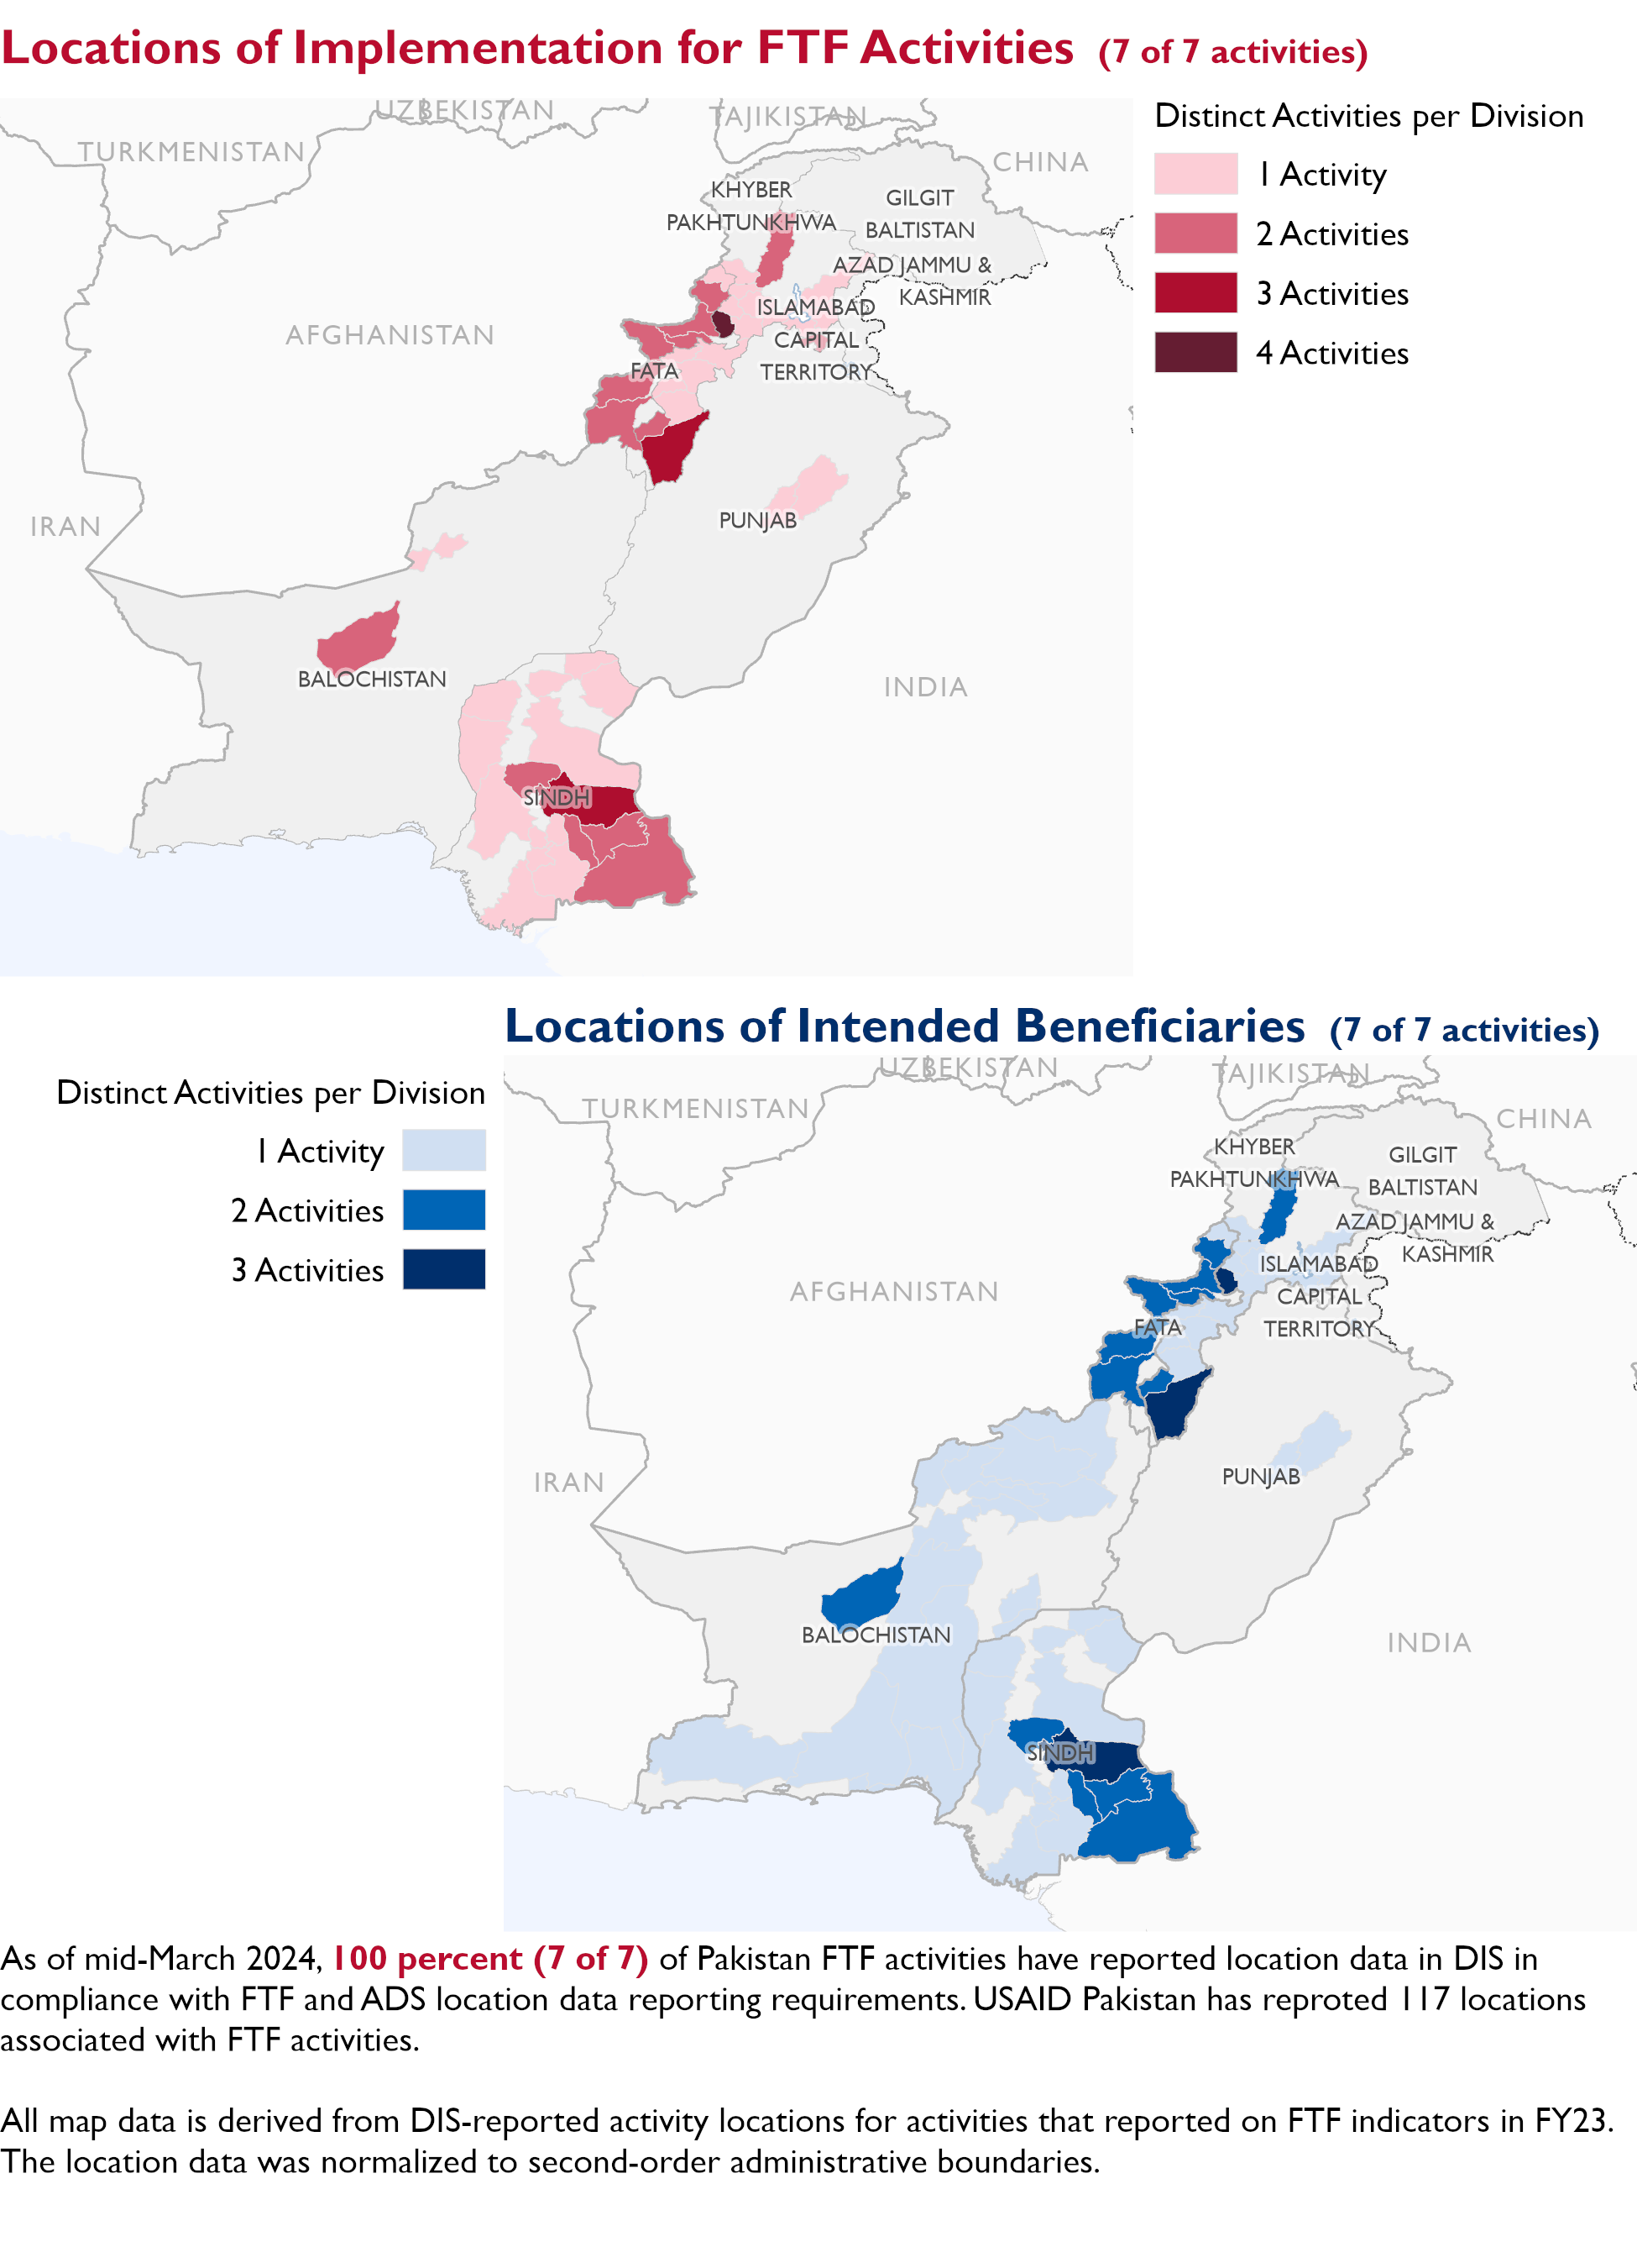

### Appendix 1: Response to “Not on track” Performance Targets

This section provides space for USAID Pakistan to provide an explanation of why the following PTs are not on track and how you could adjust to be on track in the coming year(s). To help in your response(s), the relevant section of the FTF/GFS Key Issue Narrative (KIN) is provided, as it *may be* useful in drafting a responses. Note that the KIN is addressing the sum of the out year targets (FY 2023) set by the USAID Pakistan activities that are reporting on each PT. The FY 2023 out year targets were set prior to the establishment of the FY 2030 Performance Targets, so the below explanations from the KIN may not apply to the Performance Target deviation.

* In Section 4 of the FTF KIN, your OU discusses FY24 and FY25 targets, while these Scorecards are addressing progress against a trajectory from historical reporting to your OU’s FY30 target. Also, the FY 2023 out year targets were set prior to the establishment of the FY 2030 Performance Targets. Therefore, the below explanations from the KIN may not apply to these FY30 Performance Target deviations.
* These responses will be used to compile a Congressional report, the GFSS Implementation Report, to discuss progress against the FTF FY 2030 Performance Targets, as mandated by the GAO.
* Only PTs that are ‘Not on Track’ require review and explanation from the OU.

Include the following two components in each response:

1. An explanation of why this target is not on track. Explanations may include that the OU/Mission was not aware of the target prior to planning activities. (Limit 100 words)
2. Planned actions for ‘not on track’ targets. Planned actions may include the launch of new activities, building awareness, holding portfolio reviews, or other suggestions. (Limit 100 words)

## Performance Target 1: Sales [Not on Track]

*Excerpt from FY23 KIN Section 4 to consider:* was only one FTF activity, THAzA, contributing to this indicator; the FY2023 target was unmet. The activity worked for only one quarter and then ended. It could not achieve the sale targets during the quarter as high value grants for cold storages, pack houses, packaging industry were completed in the last quarter of the activity and sales data for these interventions were not generated due to delays in implementation. The second contributing activity was the fruit orchards which started fruiting but the trees were young/small and the production volume was less due to which the target remained under achieved. There are no out years as the activity contributed to this indicator ended during FY 2023.

#### Enter USAID Pakistan’s explanation of why this target is ‘Not on track’ below (Limit 100 words):

#### Enter USAID Pakistan’s planned actions for ‘Not on track’ targets below (Limit 100 words):

## Performance Target 3: Hectares under climate adaptive and risk management practices [Not on Track]

*Excerpt from FY23 KIN Section 4 to consider:* targets for FY2023 was 76,552.4 hectares and achievement was 38,981.79 hectares. The FY 2023 target was unmet. The main reason for under-achievement was attributed to the delays in the government-to-government Gomal Zam Dam Command Areas Development Project (GZD-CADP) due to the law and order situation and changes in the provincial government. The provincial assembly was dissolved and a new caretaker government was in-place which froze developmental funding due to financial crises. Moreover, due to delays caused by the flood in 2022, the government and USAID extended the project to September 2024. With this extension the backlog and planned targets are expected to be achieved. The FY 2025 targets are low as most of the activities contributing to this indicator are closing during FY 2024. These targets will be adjusted during FY 2024 based on additional information related to ongoing and new activities that will start implementation.

#### Enter USAID Pakistan’s explanation of why this target is ‘Not on track’ below (Limit 100 words):

#### Enter USAID Pakistan’s planned actions for ‘Not on track’ targets below (Limit 100 words):